Prototype Build Plan
Game title: Hacker House
Target audience:13-16 year olds
Prototype part | Responsible student | Status | Evidence
Game design | Pragya | In progress | 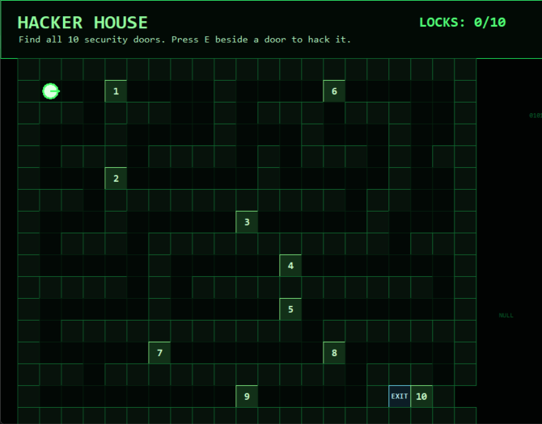
Instructions | Sujal | In progress | 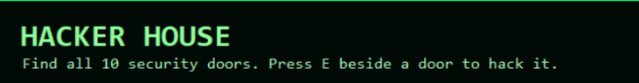
First cyber-safety challenge | Bhabuk | Not started
Player choices/options |  | Not started
Feedback message |  | Not started
Reward/score/message |  | Not started
GitHub upload/screenshots | Sujal | In progress

What will not be completed today? List what will be done in the next version.
The main menu can’t be completed today, although the main premise and mechanism of the game has been mostly completed it still lacks a reward system or any challenges besides the quizzes. It also lacks any scoring system.
In the previous session we created a story board and, in this session, we are developing the prototype v1, which will contain the core gameplay, a small instruction section.
Sujal and Pragya are responsible for various component of the first session. Screenshot of the first version is shown below.


Success criteria for today. What must work by the end of today?
By the end of the day, our team will finish the first version of the prototype which will be made during python in VS code.
The prototype must successfully include:
- Clear game instructions
- Basic game levels and navigation
- Improved visual design and layout
- Updated screenshots and evidence uploaded to GitHub
- Completion of questions that will be used in the game
Additionally, all team members must complete their assigned tasks and update their individual contribution logs.

